Industrial Mini PC
QY-B5300-4E
Small Size Series

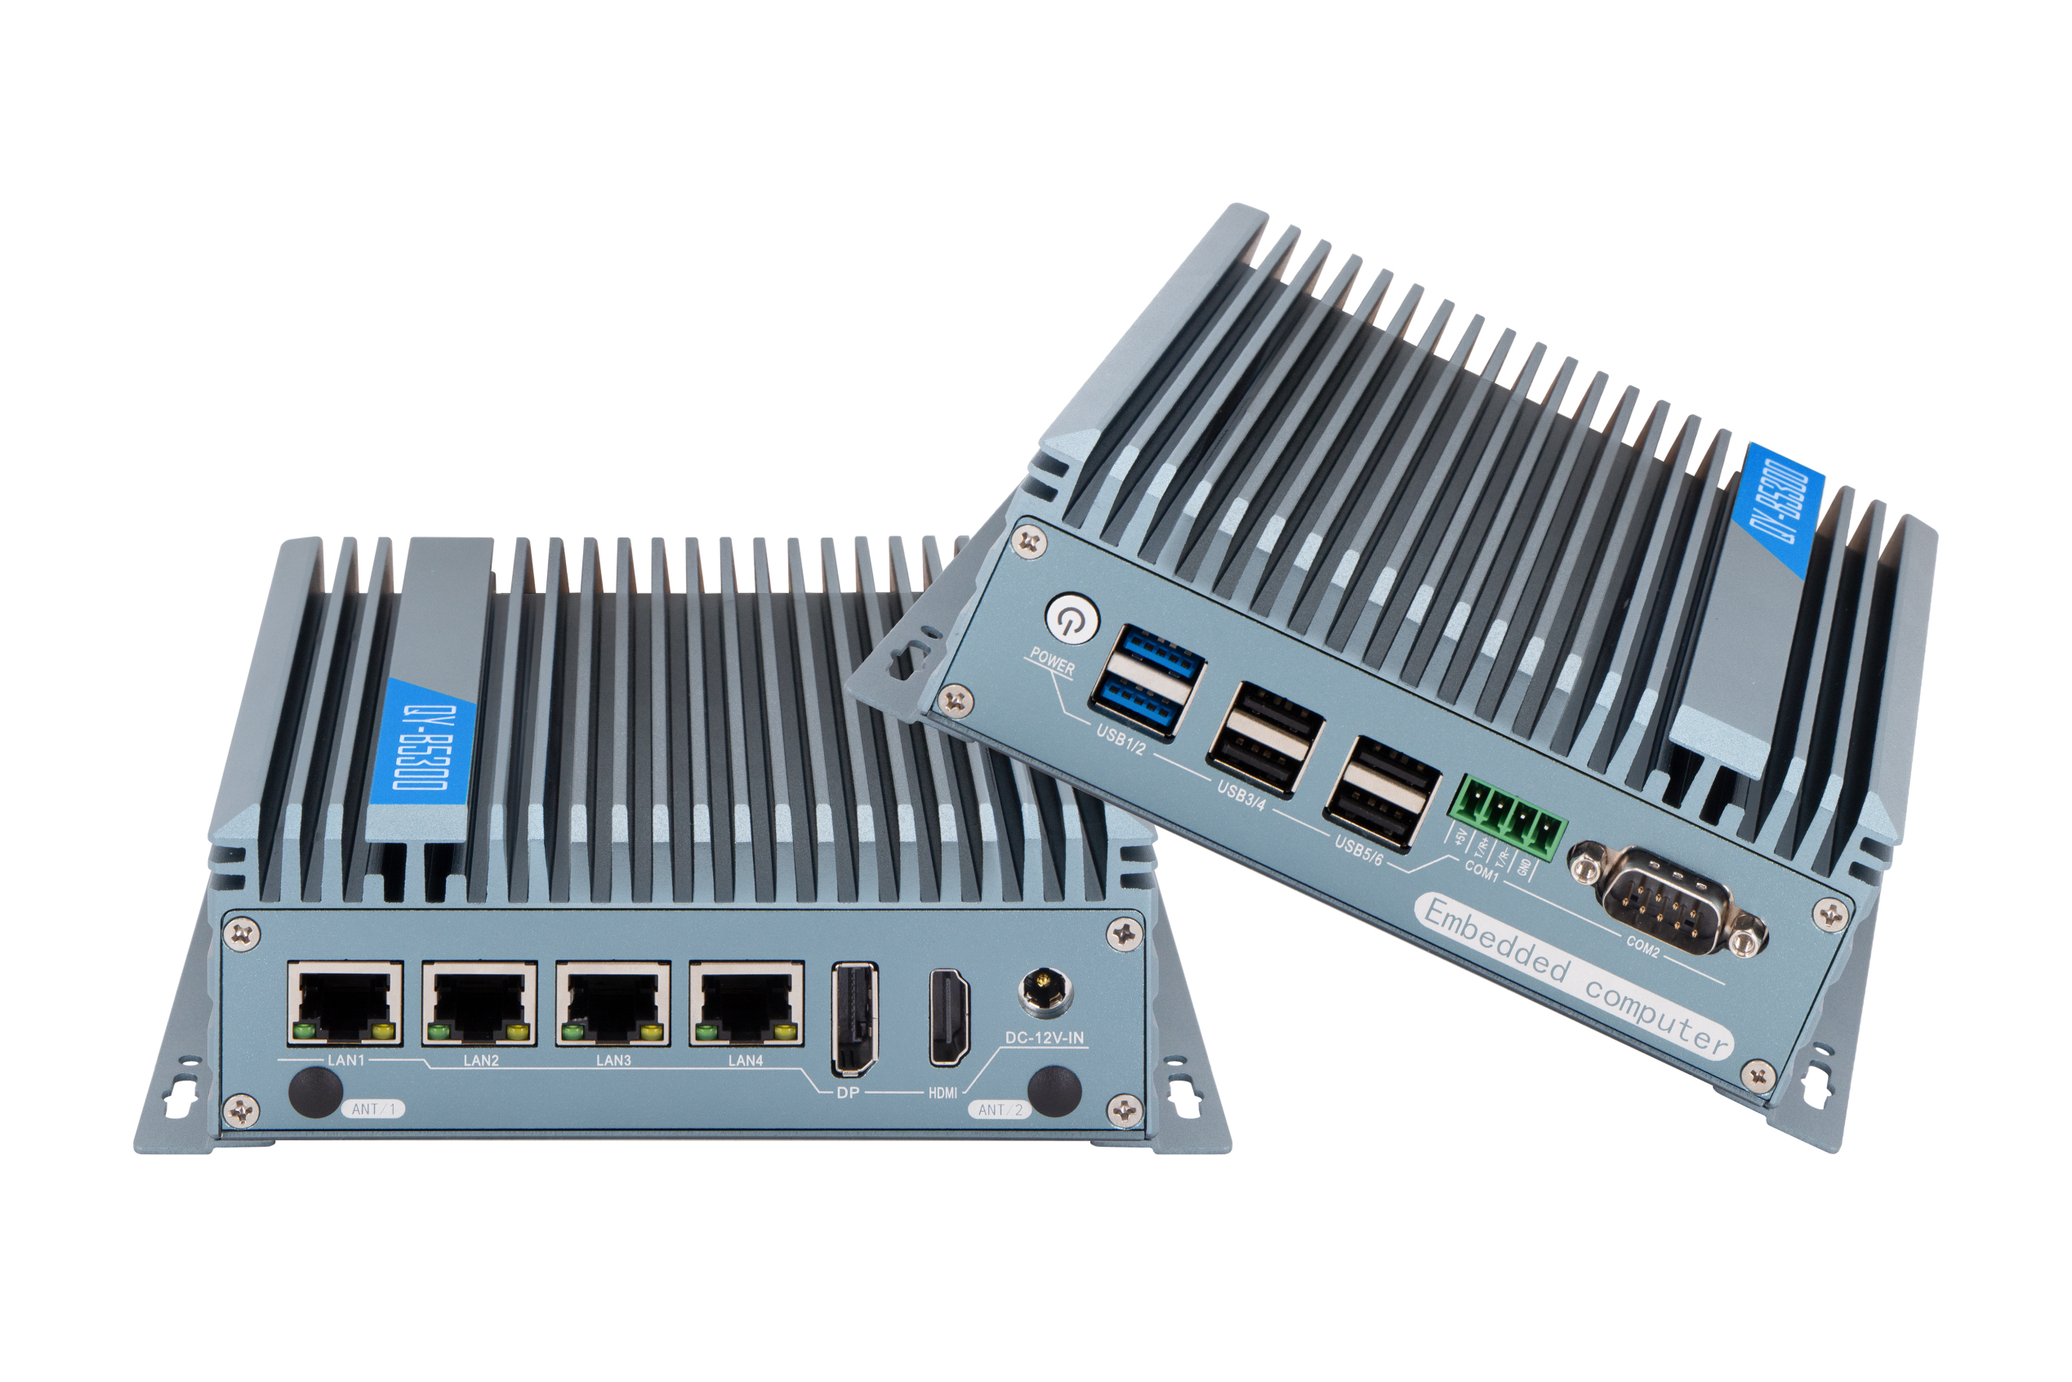
Products Features:
- Industrial-Grade Embedded Fanless Mini PC
- Intel Celeron / Atom and Core 4/5/6/7/8/10/11/12/13th-i3 / i5 / i7 CPU
- 4*LAN, 6*USB, 2*COM, *HDMI, 1*DP
- 1*Expansion Slots, Support WIFI Module
- Support Optional Fan Design Chassis
- DC 12V Power Input
- -20℃~60℃ Temperature Can Keep 24/7 Work Stably
QY-B5300-4E
1.Mother Board Specification:
Model | QY-B5300-6C
CPU | J6412 | N100
Memory | 1*DDR IIII RAM Slot, Up to 16GB
Storage | 1*M.2 NVME SSD Slot  1*SATA SSD Slot
Display | 1*HDMI: Resolution up to 4096*2160@60Hz  1*DP: Resolution up to 4096*2160@60Hz
Expansion | 1*Mini PCIE+1*M.2 Slots, Support WIFI module | 1*M.2 Slot, Support WIFI module
Ethernet | 4*Intel I225V LAN Chip (10 / 100 / 1000 /2500 Mbps, RJ-45 Type)
USB | 2*USB 3.0 (Type-A)  4*USB 2.0 (Type-A)
COM | 1*RS-232 (DB9 Type)  1*RS-232 (Phoenix Terminal Type)
Audio | 1*Line-Out

2.Device Specification:
QY-B5300-4E
Power Input | DC 9-36V
Power Input | Support Auto-Start
Power Input | 1*2.5mm Circle Type DC Plug
Working Temperature | -20℃~60℃, Support 24/7 Working
Structure | Fully Enclosed Aluminum Alloy Material
Heat Dissipation | Fanless Design, Conduction Heat Dissipation
Heat Dissipation | Fan design Chassis (optional)
Installation | Desktop / Embedded / Wall Mount
Size | 159.6mm*127mm*53mm
System | Windows and Linux

QY-B5300-4E
3.Ordering Information:
Model | CPU | LAN | USB | COM | Display | RAM | SSD | Expansion | Power
QY-B5300-1 | N2840 / J1900  4th / 5th | 2 | 6 | 2*RS-232 | 1*HDMI  1*VGA | 1*DDR 3  Up to 8GB | 1*MSATA  1*SATA | 1*Mini PCIE | DC 12V
QY-B5300-2 | J6412 | 2 | 4 | 2*RS-232/485 | 2*HDMI  1*DP | 1*DDR 4  Up to 16GB | 1*MSATA  1*SATA | 2*Mini PCIE | DC 12V
QY-B5300-2 | N95 / N100 |  |  |  |  |  | 1*M.2 NVME  1*SATA | 2*M.2 | DC 12V
QY-B5300-3 | 6th / 7th | 2 | 8 | 2*RS-232 | 1*HDMI  1*VGA | 1*DDR 4  UP to 16GB | 1*M.2 NVME  1*SATA | 1*Mini PCIE | DC 12V
QY-B5300-3 | 8th / 10th |  |  |  |  | 2*DDR 4  UP to 32GB | 1*M.2 NVME  1*SATA | 1*Mini PCIE | DC 12V
QY-B5300-3 | 12th / 13th |  |  |  |  | 1*DDR 5  Up to 32GB | 1*M.2 NVME  1*SATA | 1*Mini PCIE | DC 12V
QY-B5300-4E | J6412 | 4 | 6 | 2*RS-232 | 1*HDMI  1*DP | 1*DDR 4  Up to 16GB | 1*M.2 NVME  1*SATA | 1*Mini PCIE  1*M.2 | DC 12V
QY-B5300-4E | N100 |  |  |  |  |  | 1*MSATA  1*SATA | 1*M.2 | DC 12V
QY-B5300-6C | J6412 | 2 | 4 | 2*RS-232/485  4*RS-232 | 2*HDMI  1*DP | 1*DDR 4  Up to 16GB | 1*MSATA  1*SATA | 2*Mini PCIE | DC 9-36V
QY-B5300-6C | N95 / N100 |  |  |  |  |  | 1*M.2 NVME  1*SATA | 2*M.2 | DC 9-36V

QY-B5300-4E
4.CPU Information:
CPU | Specification
J6412 | 4 core, 4 total threads, 2.00 GHz to 2.60 GHz, 4 MB cache | Max to 16GB for 1*RAM 4 slot
N100 | 4 core, 4 total threads, 3.40 GHz, 6 MB cache | Max to 16GB for 1*RAM 4 slot

5.System Information:

CPU | System
J6412 / N100 | Windows 10 / 11and Linux

6.Fittings Information:
RAM | DDR 4 | 4GB / 8GB / 16GB
Storage | M.2 NVME | 128GB / 256GB / 512GB / 1TB / 2TB / 4TB
Storage | SATA | 120GB / 128GB / 240GB / 256GB / 480GB / 512GB / 960GB / 1TB / 2TB / 4TB
WIFI Module | 7260AC / AX210

7.Package List:

Adapter | 1*12V 5A Adapter
Power Cable | 1*Power Cable

8.Fan Design Chassis:
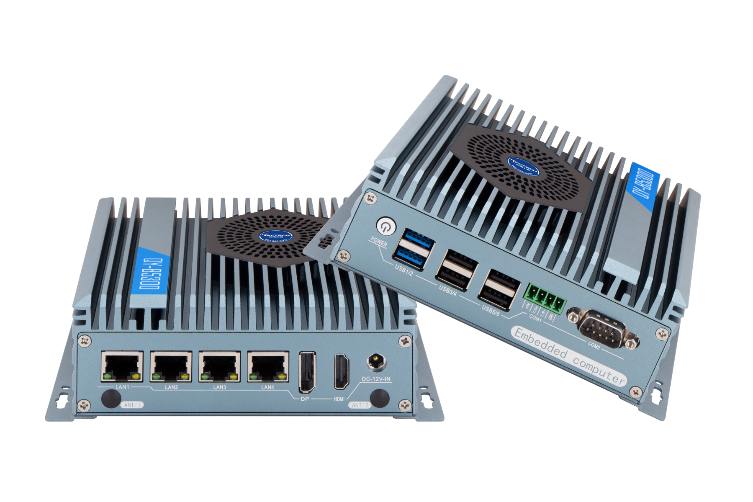
QY-B5300-4E
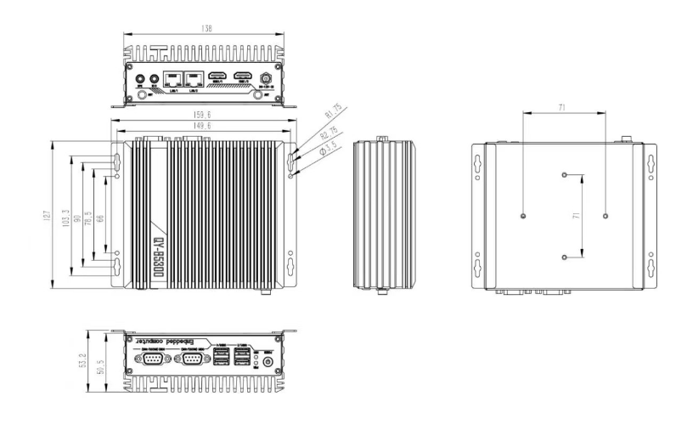
9.Dimensions:
QY-B5300

